You must come up with cluster configuration of Mongo DB where there will be one Primary and 2 Secondary nodes be present.

After firing these command:

C:\Program Files\MongoDB\Server\3.4\bin>start /b mongod --replSet rs --dbpath rs1 --port 37017 --logpath logs\rs1.log --logappend

C:\Program Files\MongoDB\Server\3.4\bin>start /b mongod --replSet rs --dbpath rs2 --port 37018 --logpath logs\rs2.log --logappend

C:\Program Files\MongoDB\Server\3.4\bin>start /b mongod --replSet rs --dbpath rs3 --port 37019 --logpath logs\rs3.log --logappend

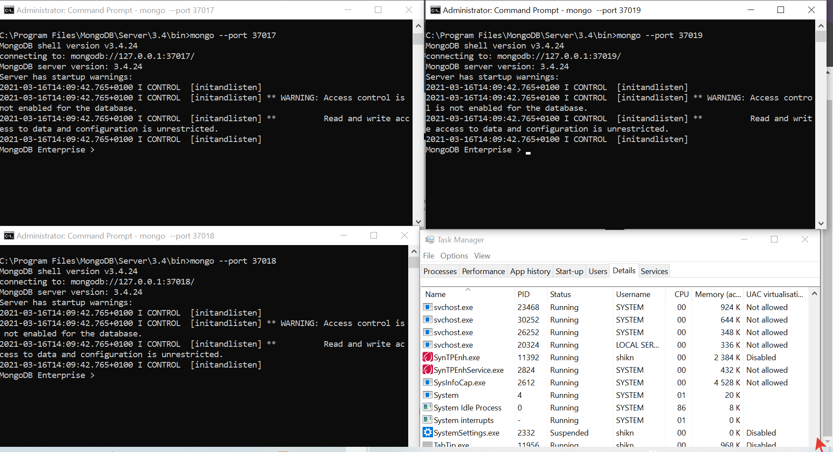O/p:

Connect with Mongo:

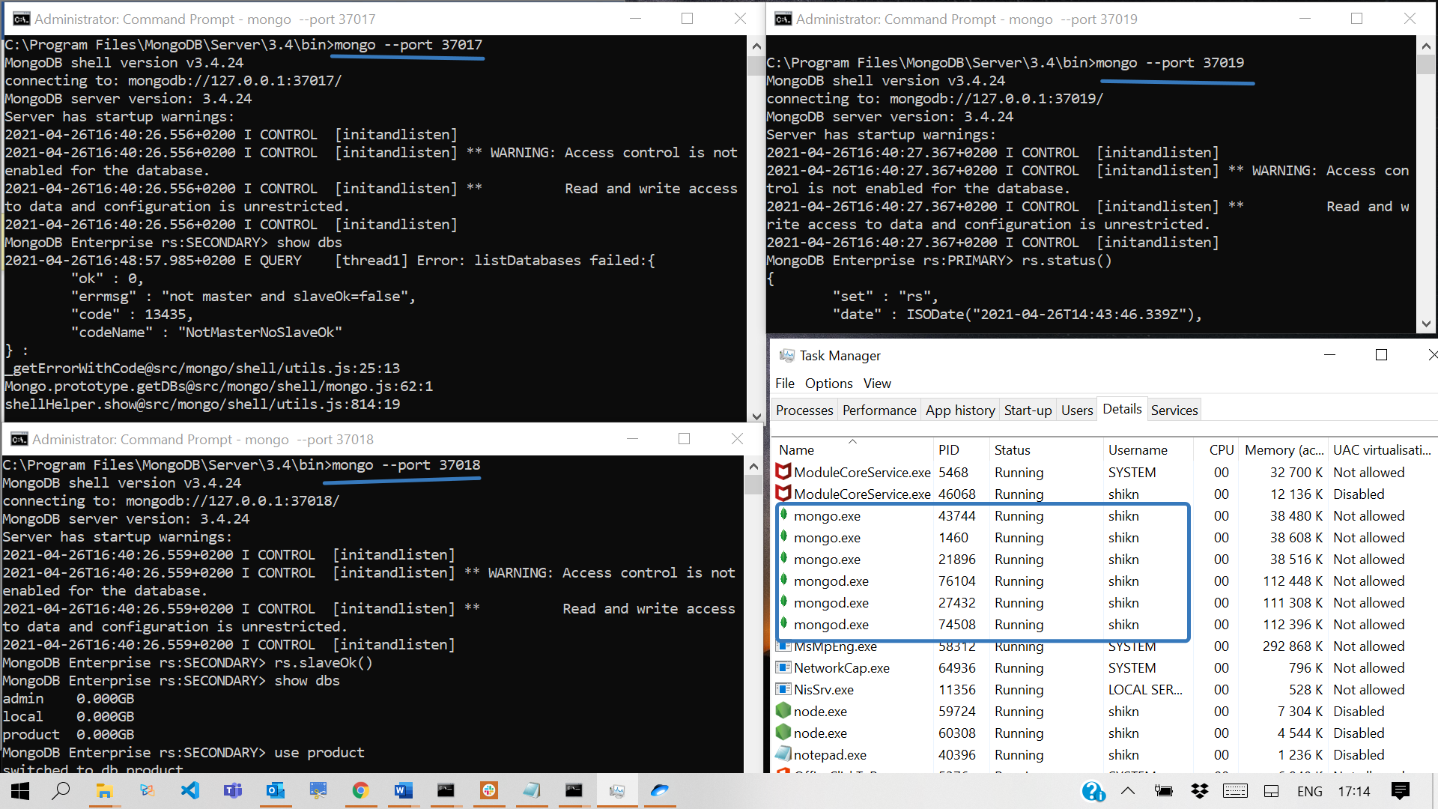

Check: Primary is responsible for writing of any data to Mongo. Secondary is responsible for reading data

